**Implementing a Superclass Employee**

William Keller

Colorado State University Global

CSC372: Programming 2

Gottipamula, Santosh

7-20-25

**Implementing a Superclass Employee**

Test Class

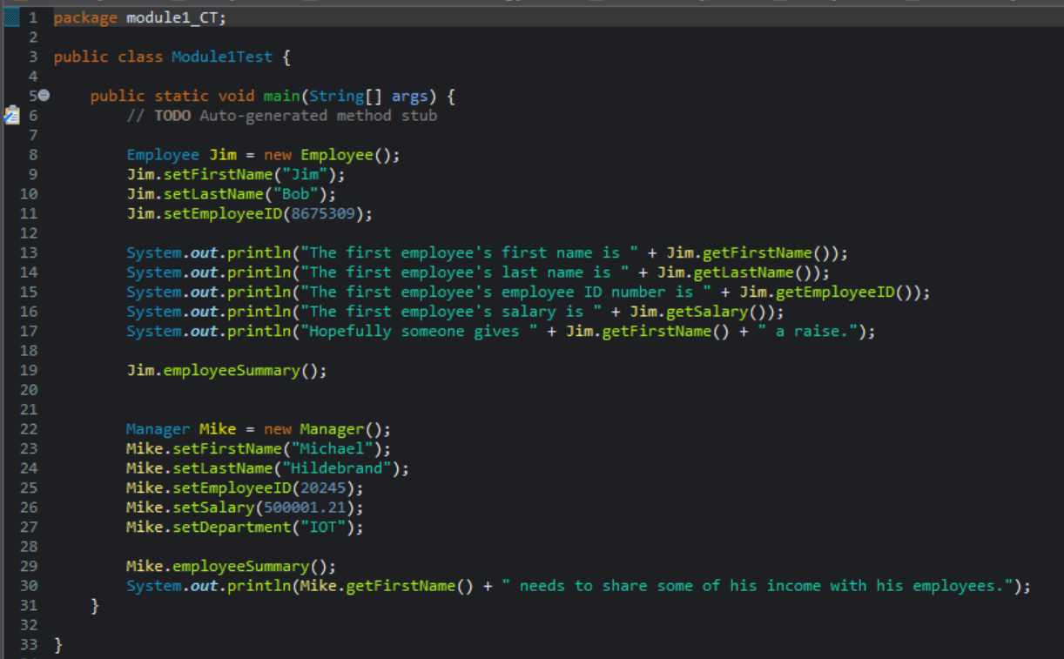

Employee Class

Manager Class

Github

<https://github.com/Strungul/CSC372>

